THE STUMPS 2011 Schedule
WWW.STUMPSDAYTON.COM
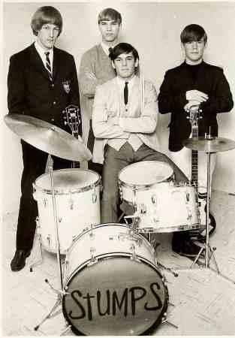
(Dates are being added, please check often for updates!)
http://www.stumpsdayton.com/upcoming.shows.htm

May 14th 2011 8pm
Alex's Continental Inn
125 Monarch Lane
Miamisburg, OH

May 20th 2011 8pm
Talegators
6270 Far Hills Avenue
Centerville, OH 45459

May 27th 2011 9pm
Norton's Bar and Grill
580 Lincoln Park Blvd.
Kettering OH 45429

June 17th 2011 8pm
Alex's Continental Inn
125 Monarch Lane
Miamisburg, OH

June 18th 2011 - Wedding Reception

July 8th 2011 8pm
Talegators
6270 Far Hills Avenue
Centerville, OH 45459

July 16th 2011 4pm
Mary, Help of Christians Festival
954 N. Maple Avenue
Fairborn, OH
FREE ADMISSION

July 29th 2011 9pm
Norton's Bar and Grill
580 Lincoln Park Blvd.
Kettering OH 45429

August 6th 2011 8pm
Alex's Continental Inn
125 Monarch Lane
Miamisburg, OH

August 12th 2011 8pm
Talegators
6270 Far Hills Avenue
Centerville, OH 45459

August 13th 2011 -Private Reunion

August 19th 2011
Hanks Pub
2529 Patterson Road
Kettering, OH 45420

August 23rd 2011
The Fraze Pavilion – 2 Dollar Tuesday Event
695 Lincoln Park Blvd
Kettering, OH 45419

September 4th 2011 2:30pm
Kettering Holiday at Home
695 Lincoln Park Blvd
Kettering, OH 45429
FREE ADMISSION

September 9th 2011 9pm
Norton's Bar and Grill
580 Lincoln Park Blvd.
Kettering OH 45429

September 16th 2011 8pm
Talegators
6270 Far Hills Avenue
Centerville, OH 45459

September 23rd 2011 8pm
Alex's Continental Inn
125 Monarch Lane
Miamisburg, OH

A small cover charge may apply at the discretion of club management unless otherwise noted
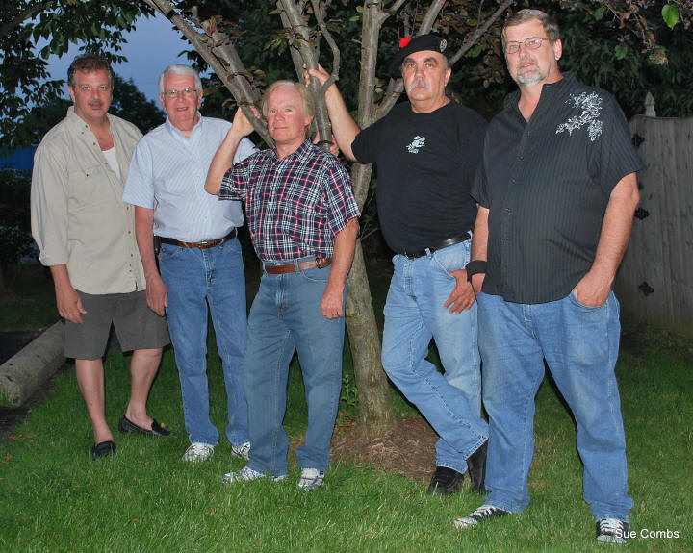

MUSIC WE PLAY:
The Kinks -The Beatles - Procal Harum - Billy J. Kramer & The Dakotas - Dave Clark Five - Santana - The Temptations - Steppenwolf - Rare Earth - Van Morrison - Marshall Tucker Band - The Rascals - Manfred Mann - The Swingin' Medallions - Lovin' Spoonful - Tommy Tutone - Buffalo Springfield - The Yardbirds - The Youngbloods - Spencer Davis Group - Creedence Clearwater Revival - The McCoys - The Turtles - Marvin Gaye - Martha & The Vandellas - The Tremelos - Rolling Stones - The Monkees - Tommy James & The Shondells - The Strangeloves - ZZ Top - Jethro Tull - The Searchers - Chuck Berry - Wilson Pickett - The Temptations- Moody Blues - Bob Seger - Henry Mancini - Bruce Springsteen - Joe Walsh - Guess Who - Grand Funk Railroad - Classics Four - Jimi Hendrix - Neil Diamond - The Box Tops -The Stumps - The Outsiders - Nashville Teens - Bee Gees - The Animals - The Romantics - Eric Clapton - Cream - The Troggs

